COMSATS University Islamabad

LINEAR CIRCUIT ANALYSIS

Lab No. 05

|  |  |
| --- | --- |
| Name | CPE122-LINEAR CIRCUIT ANALYSIS |
| Registration Number | FA24-BCE-018 and FA24-BCE-019 |
| Class | LINEAR CIRCUIT ANALYSIS |
| Instructor’s Name | Prof. Khurram Ali |

**Date : 19th-october-2024**

**Voltmeter and Ammeter Design Using Galvanometer**

**Objective:**

The main objective is to design a Voltmeter and an Ammeter using a Galvanometer by calculating appropriate resistances and observing how the designed instruments measure voltage and current.

**Introduction:**

In this lab, we aim to convert a Galvanometer into a Voltmeter and an Ammeter by adding resistances in series and parallel

**Equipment:**

* Galvanometer (sensitivity: 1 mA, internal resistance: 140 Ω)
* Resistors
* Power Supply (5V)
* DMM (for cross-checking values)
* Connecting Wires
* Breadboard

.

**: Designing the Voltmeter:**

We Convert the Galvanometer into a Voltmeter by adding a high-value resistor in series.

Will Use the formula to calculate the series resistor R

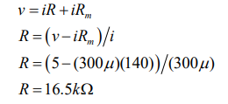

**Measurement of the internal resistance of Galvanometer:**

**To calculate the actual value of the internal resistance of the galvanometer:**

1) Measure the voltage across the sensitive galvanometer

2) Measure the current flowing through the galvanometer

3) Write down in the calculated and measured value of the internal resistance Rm.

4) Determine the calculated value of R Use DMM to measure the value of series resistance R

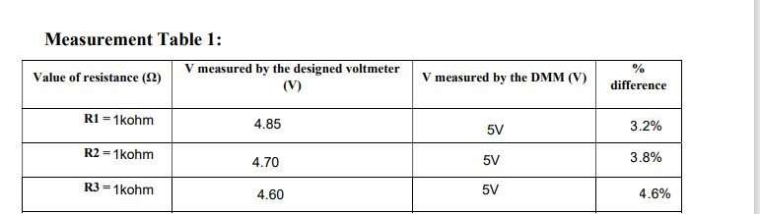

Figure Galvanometer to Voltmeter Values

**: Designing the Ammeter:**

To Convert the Galvanometer into an Ammeter by adding a low-value resistor in . parallel (shunt resistor).

Will Use this formula to calculate the shunt resistor Rs:

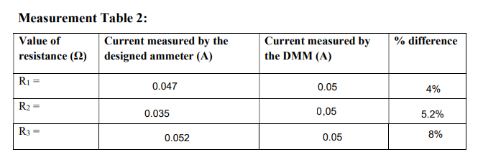

**Post Lab Questions:**

**Question 1**: What do you mean by short and open circuit? What are the values of voltages and currents in open and short circuits?

**Short Circuit:**

A condition where two points in a circuit relate to zero or very low resistance, causing a large current to flow.

* Voltage: 0V across the short.
* Current: Very high (theoretically infinite, limited by the power source and circuit).

**Open Circuit:**

A break or disconnection in the circuit, causing no current to flow.

* Voltage: Full supply voltage across the open points.
* Current: 0A (no current flows).

**Question 2:** Why high resistance is a desirable attribute of voltmeter?

**Answer:** High resistance in a voltmeter is desirable because it minimizes the current drawn from the circuit being measured. This prevents the voltmeter from affecting the circuit's operation and ensures more accurate voltage measurements. If the voltmeter had low resistance, it would allow more current to flow through it, potentially altering the voltage across the components in the circuit.

**Question 3**: What is the basic motivation behind converting galvanometer into ammeter?

**Answer:** Galvanometer is mainly use for detecting and measuring small currents by converting galvanometer into ammeter we can measure larger currents

**Date: 11th October 2024**